***Section* 3.7 – Power Series**

**Power Series and Converge**

***Definitions***

A **power series about *x* = 0** is a series of the form 

A **power series about**  is a series of the form



In which the ***center*** *a* and the ***coefficients***  are constants.

***Example***

Find the convergence of 

***Solution***

This is the geometric series with first term 1 and ratio *x*. it converges to 



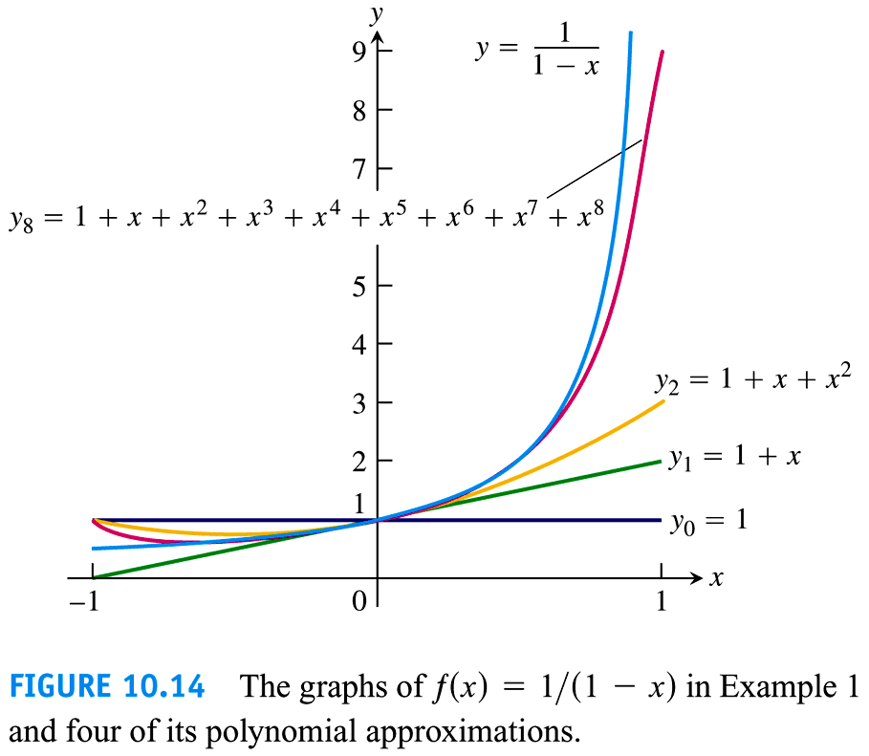

***Example***

The power series 

This is the geometric series with first term 1 and ratio . it converges to . The sum







The series generates polynomial approximations of  for values of *x* near 2:







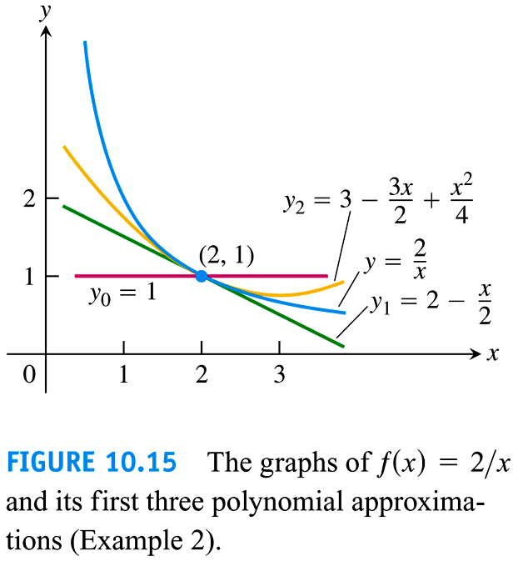

***Example***

For what values of *x* do the power series converges? 

***Solution***





The series converges absolutely for . It diverges if .

At , we get the alternating harmonic series , which converges.

At , we get the alternating harmonic series , the negative of the harmonic series; it diverges.

The series ***converges*** for  and ***diverges*** elsewhere.



***Example***

For what values of *x* do the power series converges? 

***Solution***





The series converges absolutely for . It diverges if .

At , we get the alternating harmonic series , which converges.

At , we get the alternating harmonic series , it converges.

The series ***converges*** for  and ***diverges*** elsewhere.



***Example***

For what values of *x* do the power series converges? 

***Solution***





The series ***converges absolutely*** for all *x*.



***Example***

For what values of *x* do the power series converges? 

***Solution***





The series ***diverges*** ***absolutely*** for all *x* except *x* = 0.



***Theorem***

If the power series  converges at , then it converges absolutely for all *x* with . If the series diverges at , then it diverges for all *x* with .

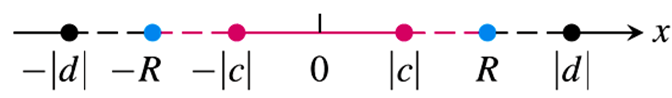

**Radius of Convergence of a Power Series**

***Corollary to Theorem***

The convergence of the series  is described by one of the following three cases:

1. There is a positive number *R* such the series diverges for *x* with  but converges absolutely for *x* with . The series may or may not converge at either of the endpoints  and .
2. The series converges absolutely for every *x* .
3. The series converges at *x* = *a* and diverges elsewhere (*R* = 0)

*R* is called the ***radius of convergence*** of the power series, and the interval of radius *R* centered at *x = a* is called the ***interval of convergence***.

***Definition***

Suppose that  exists or is ∞. Then the power series  has radius of convergence . (If *L* = 0, then *R* = ∞; if *L* = ∞, then *R* = 0) and

***How to Test a Power Series for Convergence***

1. Use the Ratio Test (or Root Test) to find the interval where the series converges. Ordinarily, this is an open interval



1. If the interval of absolute convergence is finite, test for convergence or divergence at each endpoint. Use the Comparison Test, the Integral Test, or the Alternating Series Test.
2. If the interval of absolute convergence is , the series diverges for  (it does not even converge conditionally) because the *n*th term does not approach zero for those values of *x*.

***Example***

Determine the centre, radius, and interval of convergence of 

***Solution***



The centre of convergence is











The series converges absolutely on ***interval***

 

It diverges on 

At 

At 

Both series ***converge*** (*absolutely*).

Therefore; the interval of convergence of the given power is 

***Example***

Determine the radius of convergence of 

***Solution***

|  |  |
| --- | --- |
| Thus | ***Or*** |

This series ***converges*** (*absolutely*) for all *x*.

***Example***

Determine the radius of convergence of 

***Solution***







Thus 

This series ***converges*** only at its centre of convergence, *x* = 0.

***Theorem* − The Series Multiplication Theorem for Power Series**

If  and  converge absolutely for , and



Then  converges absolutely to  for :



Finding the coefficients 







***Theorem***

If  converges absolutely for , then  converges absolutely for any continuous function  on 

***Theorem* − The term-by-Term Differentiation Theorem**

If  has a radius of convergence *R* > 0, it defines a function.



This function  has derivatives of all order inside the interval, and we obtain the derivatives by differentiating the original series term by term:





And so on. Each of these derived series converges at every point of the interval 

***Example***

Find the series for  and  if





***Solution***







 

***Theorem* − The term-by-Term Integration Theorem**

Suppose that  converges for . Then



Converges  and



***Example***

Identify the function 

***Solution***



This is a geometric series with first term 1 and ratio , so





The series for 







***Exercises Section* 3.7 – Power Series**

(**1 − 9**)

1. Find the series’ radius and interval of convergence. For what values of *x* does the series converge (***b***) absolutely, (***c***) conditionally?

|  |  |  |
| --- | --- | --- |
|  |  |  |

(**10 − 18**) Find the radius of convergence of the power series

|  |  |  |
| --- | --- | --- |
|  |  |  |

(**19 − 42**) Find the interval of convergence of the power series

|  |  |  |
| --- | --- | --- |
|  |  |  |

|  |  |  |
| --- | --- | --- |
|  |  |  |

(**43 − 56**) Determine the centre, radius, and interval of convergence of each of the power series

|  |  |  |
| --- | --- | --- |
|  |  |  |

1. For what values of *x* does the series  converges? What is its sum? What series do you get if you differentiate the given series term by term? For what values of *x* does the new series converge? What is its sum?
2. The series  converges to sin*x* for all *x*.
3. Find the first six terms of a series for cos*x*. For what values of *x* should the series converge?
4. By replacing *x* by 2*x* in the series for sin*x*, find a series that converges to sin2*x* for all *x*.
5. Using the result in part (a) and series multiplication, calculate the first six term of a series for . Compare your answer with the answer in part (b).
6. Find the sum of the series  by the first finding the sum of the power series



1. Find a series representation of  in powers of . What is the interval of convergence of this series?
2. Determine the Cauchy product of the series . On what interval and to what function does the product series converge?
3. Determine the power series expansion of  by formally dividing  into 1.

Use the power series 

(**63 − 65**) Determine the interval of convergence and the sum of each of the series

1. 
2. 
3. 